Destiny

School Use: http://destiny.hinghamschools.net
Home Use: 96.237.65.67 or access the Library link from the South page on http://www.hinghamschools.com

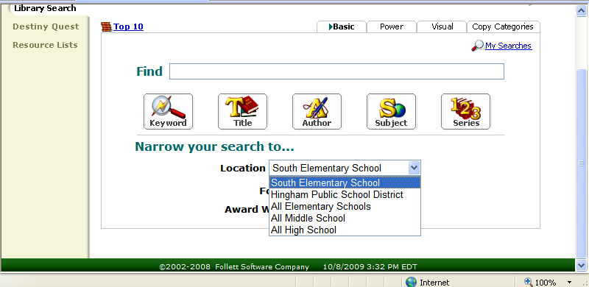

Click on South Elementary School to access our catalog.

You can click on the drop-down menu to expand your search to include other elementary schools or the entire district.

You may access the library catalog without logging-in. Logging-in allows you to check your account, create lists, place holds, and request titles for our library to purchase.

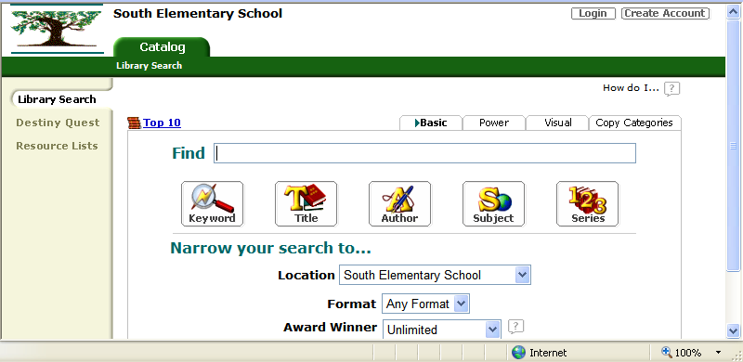
To login to your account, click on the login button in the upper right-hand corner.

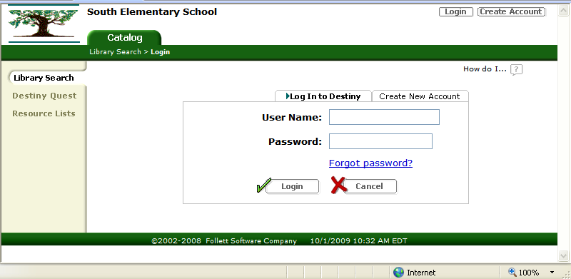
First Initial of First Name with Entire Last Name
First four letters of Last Name
Example: Jane Smith
User Name: jsmith
Password: smit

Check Your Account
Click on the My Info tab → Patron Status menu (left) to view any items you have checked out or the status of any holds you have placed.

Create Lists
Click on the My Info tab → Resource Lists menu (left) to create your own list or to view public lists. Search and select titles from the catalog to add to your list(s). There is a drop-down menu at the top of the catalog when you search under your login. You may keep your lists private or make them public so others, including students, can access them. Note: If you make lists public, they will not appear on the Public Lists tab under your login, but they will appear on others’ public tabs.

Place Holds
When you have found a title in the catalog, click on either the title hyperlink or the Details button immediately to the right. In the Title Details screen click Hold It! You can click See all to view the status of our copies and those at other schools. Holds from other schools will arrive via inter-office mail in a few days.

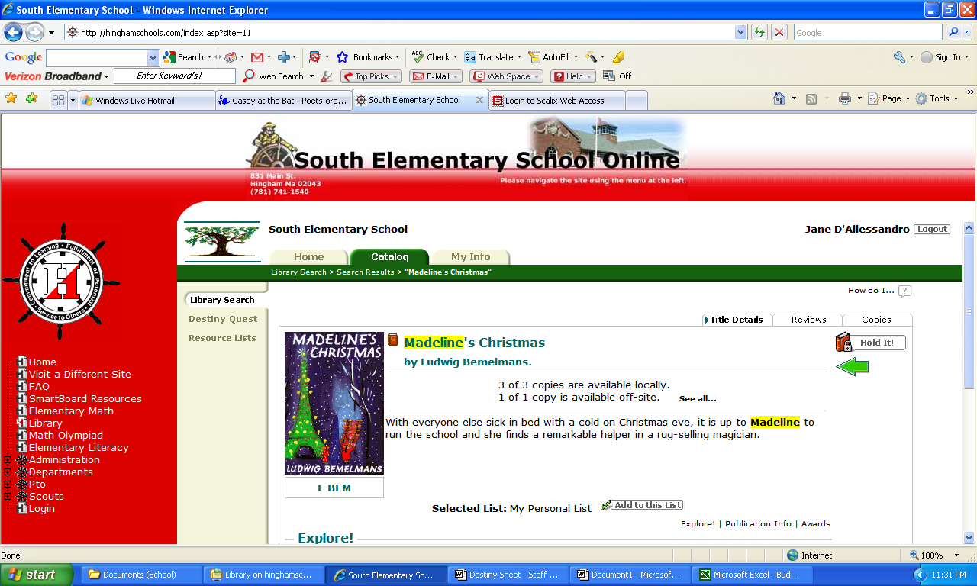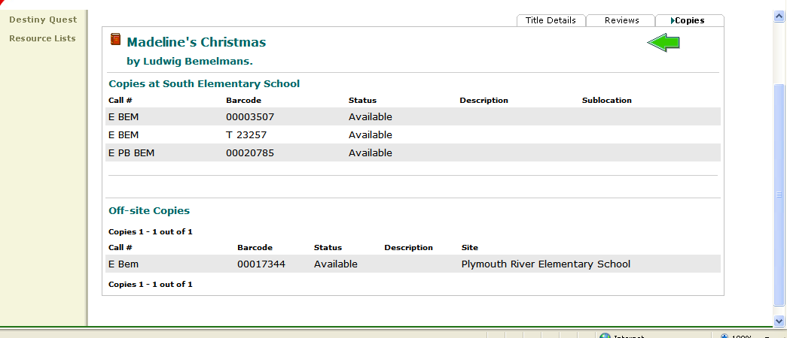

Request Titles for Purchase
When you have found a title in the catalog, click on either the title hyperlink or the Details button immediately to the right. In the Title Details screen click Wish List. You have the option of giving a reason but it is not necessary.

NOTE: Do not use your browser’s “Back” button to go back. Instead, follow the trail of “breadcrumbs” in the green bar under the tabs. Destiny keeps track of the menus you have clicked.
Click for help

